ECS 4010 Lab Task – 1

**KEIL SCREENSHOT**

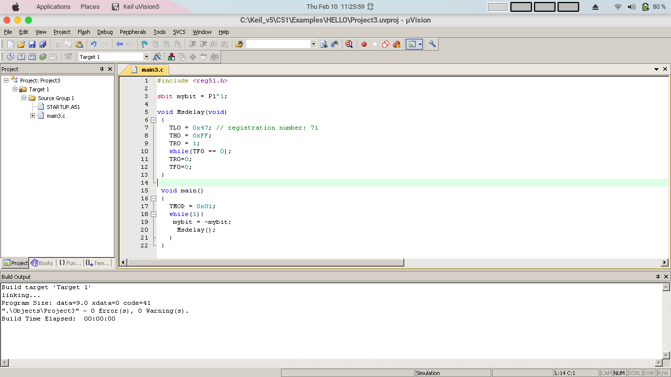

**PROTEUS SCREENSHOT**

